

University of Energy and Natural Resources

School Of Sciences,

Department of Information Technology and Decision Sciences,

**Group four**

**GROUP MEMBERS**

1. Akwei Enyo Gloria _ UEB3228922
2. Bentil Ebenezer _ UEB3234322
3. Anning Baffour _ UEB3215720
4. Thompson Junior Williams _ UEB3267822
5. Agyei Baah Derrick _ UEB3267122
6. Owusu Jessey Bethel _ UEB3270022
7. Asare Nana Kwasi _ UEB3266622
8. Lawerteh Gorden Teshiah _ UEB3202422
9. Asante Kokwa Sampson _ UEB3218020

Introduction

A study system application that connects all students, programs of study with their various courses, reading materials and other study materials, ie. Past questions, Lecture notes.

This system is developed for tertiary institutions to make studying, teaching and learning very easy and efficient.

All student can access the study system application on Play store for android users and App store for IOS users, the system application can be used on their desktops and Smart phones as well.

Students can access materials on the application using their student credentials only.

Features

1. SIGN UP: The sign up interface allows students to first create an account before they can use the application.

Sign Up Details:

1. Student Name
2. Student ID Number
3. Student Level
4. Password
5. Student Email Address

After the student has signed up, they can LOG IN anytime with their student ID and Password. Students will be able to access materials based on their program of study and level.

2. EXPLORE: The student can now navigate through to the application to access materials.

When the explore button is clicked on, it gives a drop-down interface where we have all material in category of first and second semester.

# **THE SIGN UP PAGE/INTERFACE**

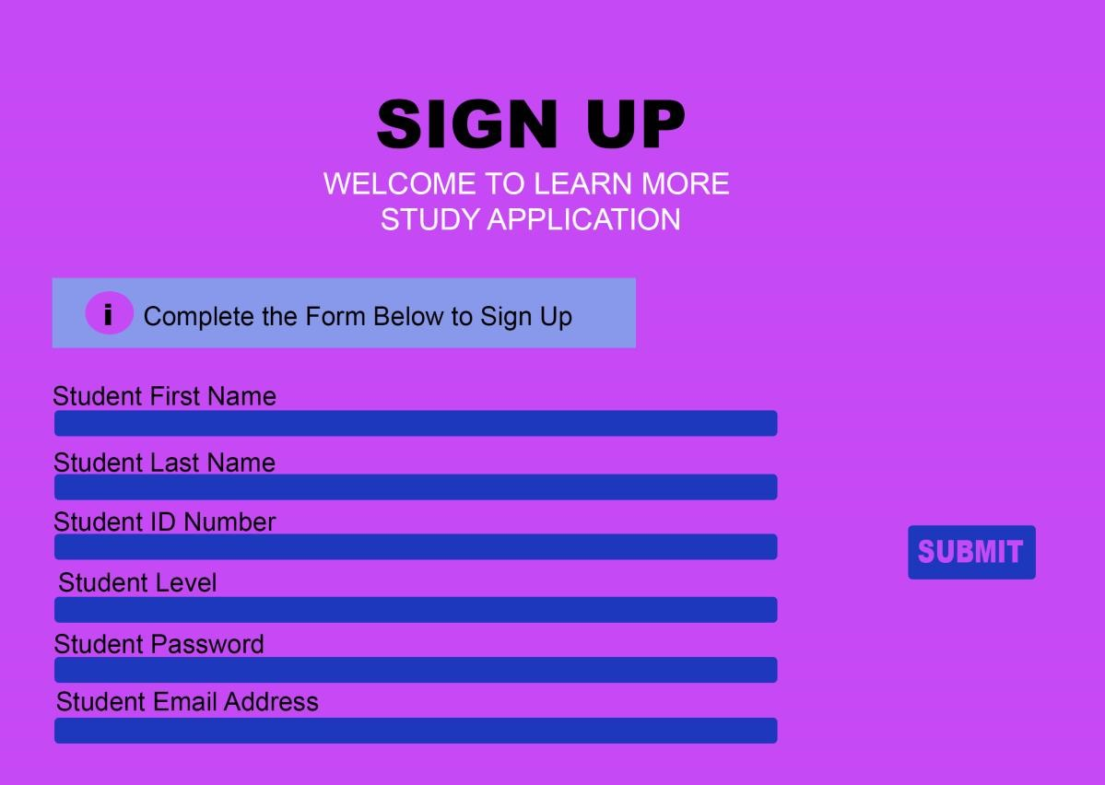

# **EXPLORE PAGE/INTERFACE**



# **USE CASE DIAGRAM**

STUDENT

LECTURER

SIGN

UP

LOG

IN

SEARCH

MATERIALS

VIEW DOCS

AND

TUTORIALS

UPLOAD

NEW DOCS,

TUTORIALS

EDIT MATERIAL,

DOCS

, TUTORIAL

STUDENT

LECTURER

**USABILITY TESTING REPORTS.**

**Introduction**

The Study System Application is designed to connect students with their respective programs of study and courses, providing access to various study materials, including reading materials, past questions, and lecture notes. The application aims to enhance studying, teaching, and learning in tertiary institutions. This usability testing report highlights the testing process, user feedback, and design refinements implemented during the project.

**Usability Testing Process**

Participants: The usability testing involved 5 students from different departments in one institution, representing various programs and levels of study.

Tasks: Participants were given specific tasks to perform using the structure and documentation of the application, such as:

Sign up for a new account.

Log in using their credentials.

Explore and access materials based on their program and level.

Provide feedback on their experience with the application.

Data Collection: The usability testing was conducted using a combination of observation, video recording, and post-task questionnaires to collect both qualitative and quantitative data.

**Analysis of User Feedback:**

Sign-Up Process: The sign-up interface was found to be intuitive and straightforward. All participants successfully created their accounts without any difficulties.

Login Process: Participants had no issues logging in using their student ID and password.

Explore Functionality: The "Explore" feature was well-received, and the dropdown interface provided an organized way for students to access materials by categorizing them based on the first and second semesters.

Material Accessibility: Students appreciated the easy access to study materials tailored to their specific program and level. The filtering mechanism based on program and level was highly praised.

Mobile and Desktop Usability: The application will perform well on both mobile devices and desktops. However, some users suggested minor improvements in the mobile layout for better optimization.

Performance and Speed: Overall, the application will demonstrate good performance and speed, allowing students to access materials quickly.

Security: Students felt confident about their data's security, as the application required their student credentials for access.

Suggestions: Some users recommended additional features like a search bar for materials and the ability to highlight or annotate study materials.

**Design Refinements**

Based on the user feedback, the following design refinements were implemented:

Mobile Layout Optimization: The mobile layout was improved to ensure seamless navigation and enhanced user experience on smaller screens.

Search Functionality: A search bar was added to facilitate easy material discovery.

Highlight and Annotation: A feature to highlight and annotate study materials was incorporated, allowing students to personalize their notes.

Performance Optimization: Minor performance optimizations were made to further enhance the application's speed and responsiveness.

**Conclusion**

The usability testing process provided valuable insights into the

Study System Application's strengths and areas for improvement. The positive feedback on the sign-up process, login functionality, and material accessibility validated the application's core objectives.

Implementing design refinements based on user feedback enhanced the overall user experience, making studying, teaching, and learning even more efficient and user-friendly.

The Study System Application is now better equipped to meet the needs of students in tertiary institutions, providing them with a valuable tool for their academic journey